3. Write a C program that will create three child process to perform the following operations
respectively:
- First child will copy the content of file1 to file2
- Second child will display the content of file2
- Third child will display the sorted content of file2 in reverse order.
- Each child process being created will display its id and its parent process id with
appropriate message.
- The parent process will be delayed for 1 second after creation of each child process. It
will display appropriate message with its id after completion of all the child
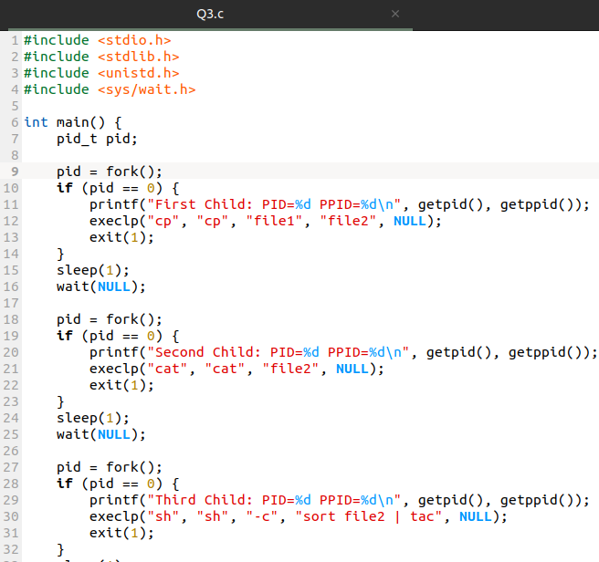
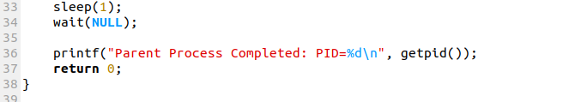
processes.

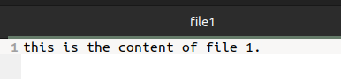

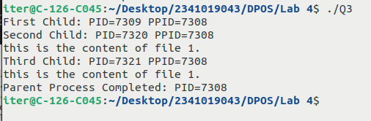

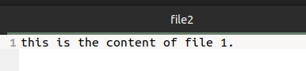

4. Write a C program that will create a child process to generate a Fibonacci series of specified
length and store it in an array. The parent process will wait for the child to complete its task
and then display the Fibonacci series and then display the prime Fibonacci number in the
series along with its position with appropriate message.

